Prefix to Infix Conversion
Problem Statement: You are given a valid arithmetic expression in prefix notation. Your task is to convert it into a fully parenthesized infix expression.
Prefix notation (also known as Polish notation) places the operator before its operands. In contrast, infix notation places the operator between operands.
Your goal is to convert the prefix expression into a valid fully parenthesized infix expression.
Examples
Example 1:
Input: expression = "+ab
Output: (a+b)

Example 2:
Input: expression = "*+ab-cd
Output: ((a+b)*(c-d))
Algorithm
Traverse the prefix expression from right to left.
- Use a stack to store operands.
- For each operator, pop two operands from the stack, wrap them in parentheses, and push the resulting expression back.
- The final item in the stack will be the infix expression.

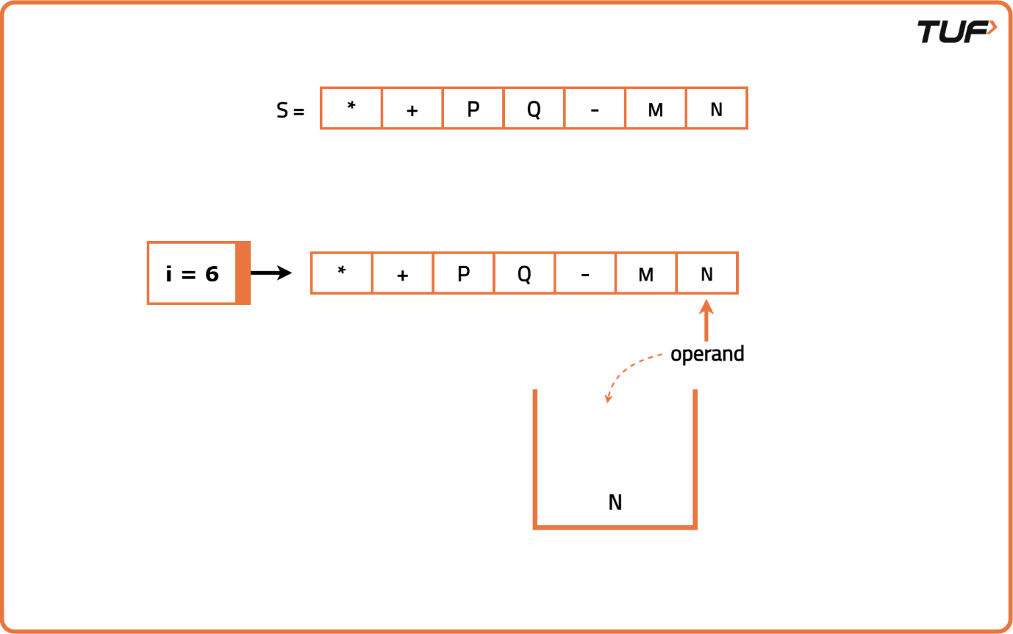
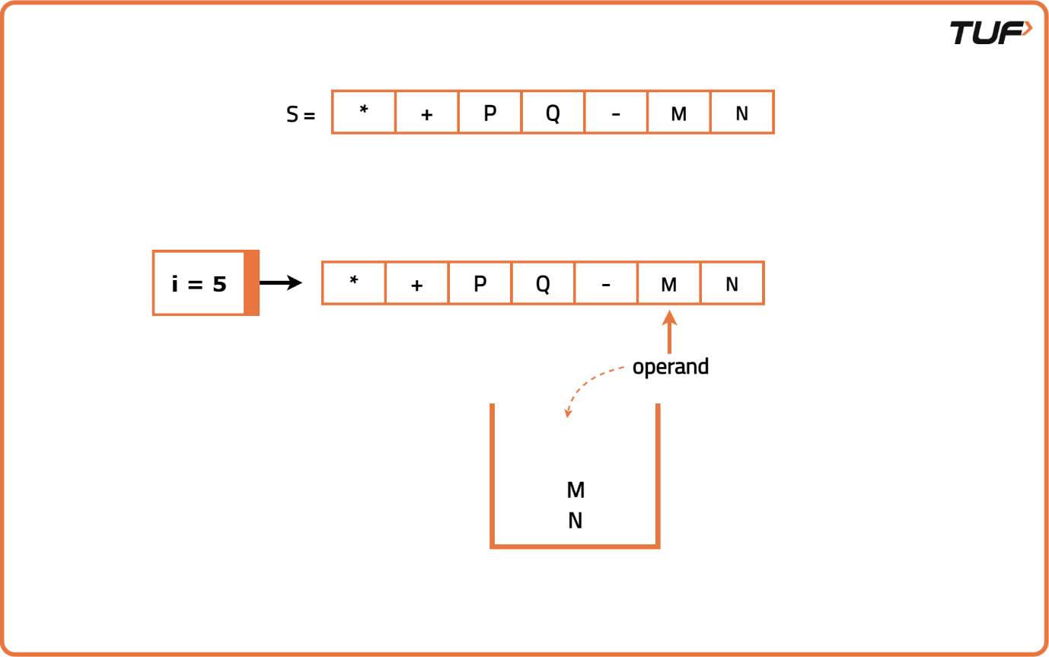
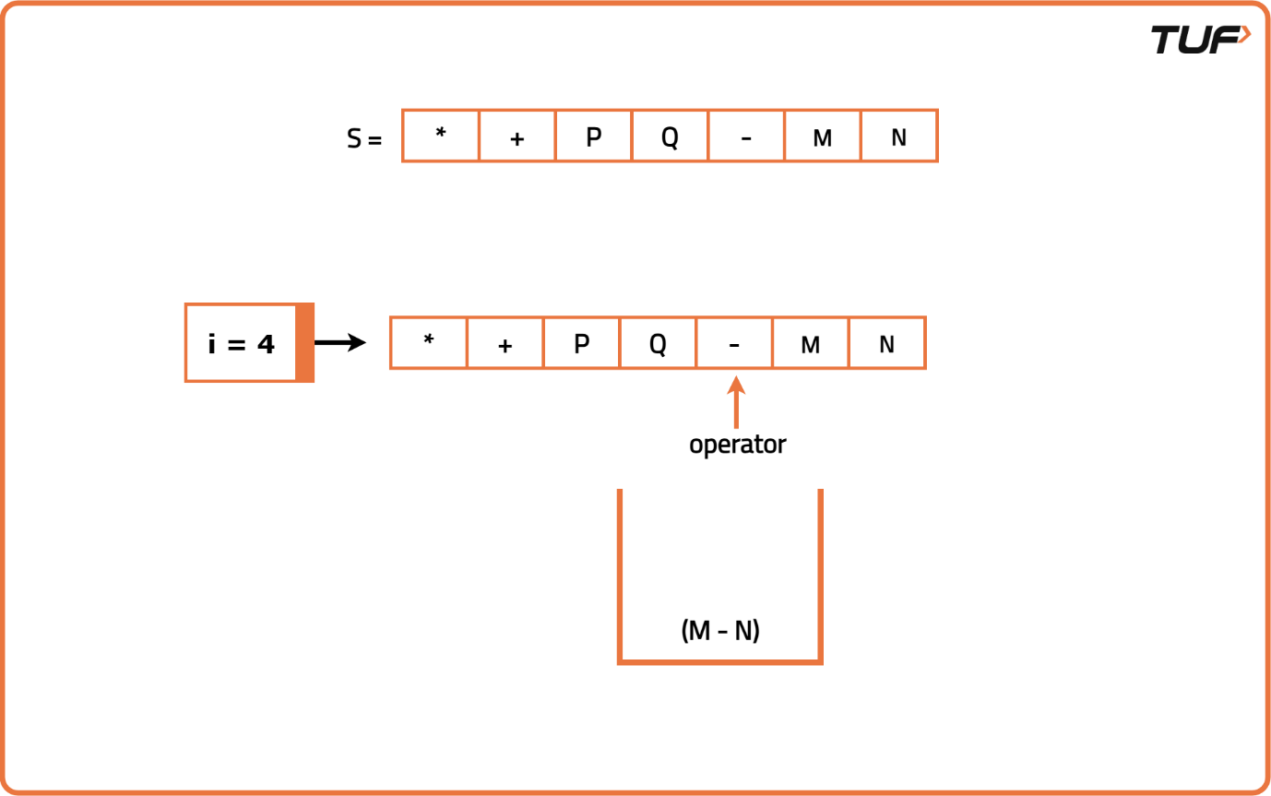
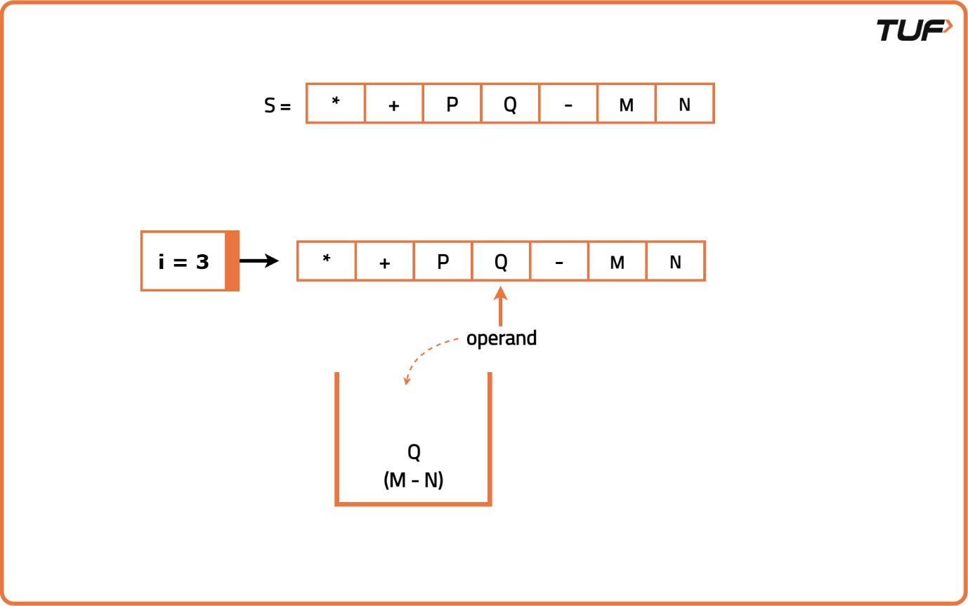
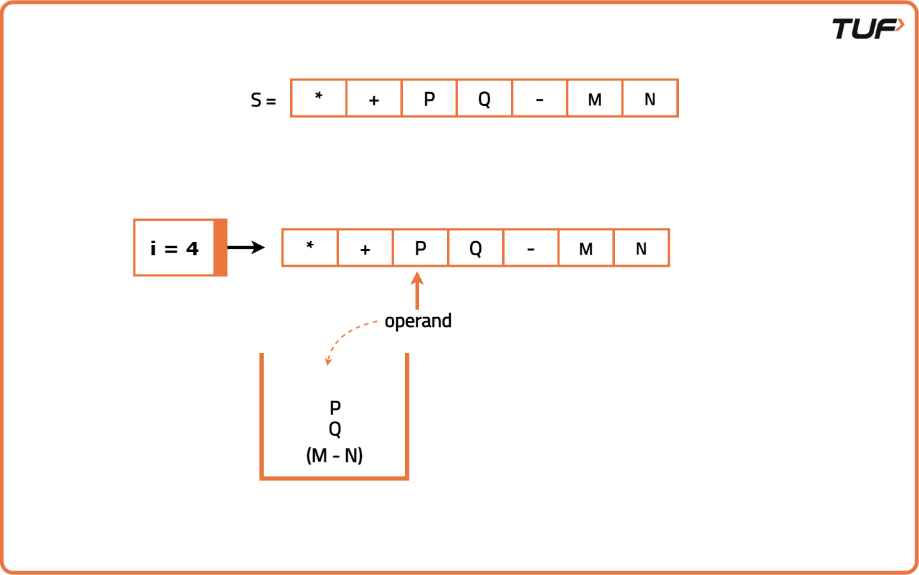
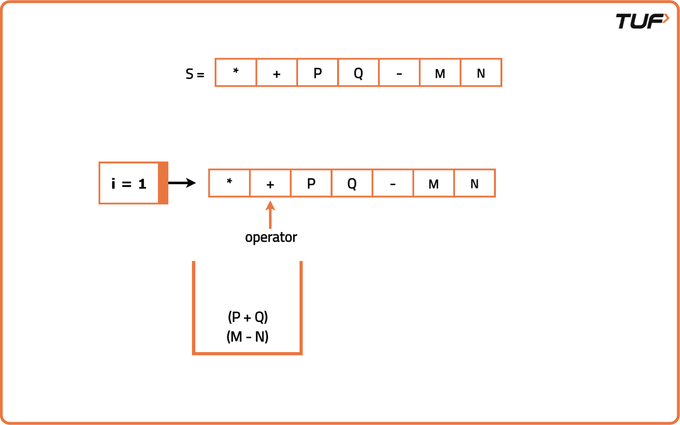
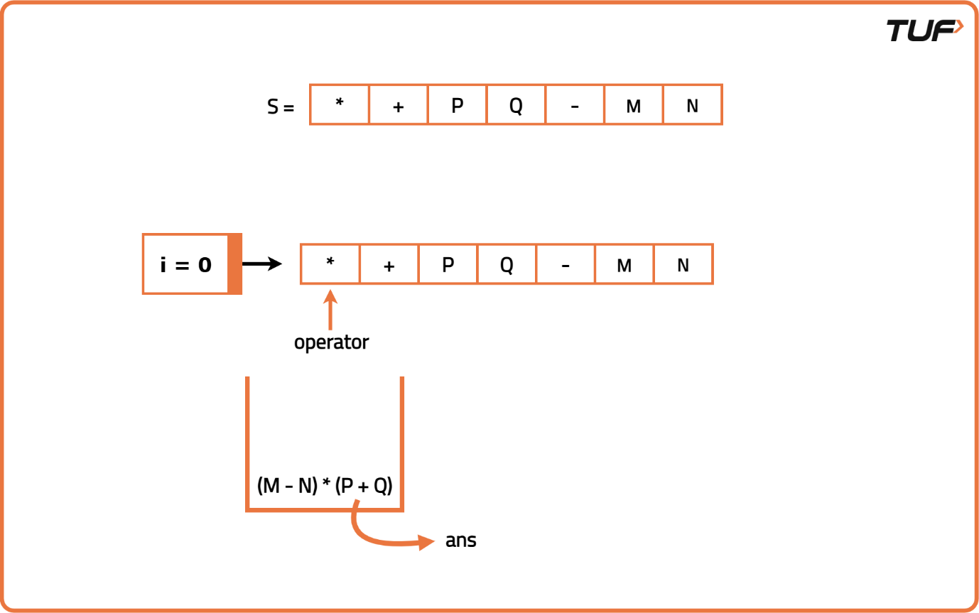

import java.util.*;

class PrefixToInfix {
// Function to convert prefix to infix
public String prefixToInfix(String prefix) {
Stack<String> s = new Stack<>();
int n = prefix.length();

// Traverse the prefix expression from right to left
for (int i = n - 1; i >= 0; i--) {
char c = prefix.charAt(i);

// If the character is an operand, push it to the stack
if (Character.isLetterOrDigit(c)) {
s.push(String.valueOf(c));
} else {
// Pop two operands from the stack
String op1 = s.pop();
String op2 = s.pop();

// Form the new infix expression and push back to stack
s.push("(" + op1 + c + op2 + ")");
}
}

// The final element in the stack is the result
return s.peek();
}
}

